

St. Louis Bridge Center Newsletter

**The St. Louis Bridge Center will be closed Friday, Saturday and Sunday, October 18-20, in support of the St. Louis Fall Sectional in St. Charles.**



To our newest SLBC Members………………..

Allan Goodloe, Anita Phillips, William Crocker,

Kathleen Crane, Beth Lochmoeller and Diane Sher

**Monday Morning Chat Game…..**

Most of you who read our newsletter are regular players, but we need to grow our game. The CHAT GAME on Monday mornings allows players to put their toe in the water for DUPLICATE BRIDGE, where a director is present to offer teaching tips about bidding and play of the hand during the game. Please encourage friends to join us in playing bridge. DEAL ME IN!!!



To our SLBC August and September Advancers………

**New Junior Masters:** John Bolesta, David Bouchein, Juli Timney, Paul Vandivort, Steve Walko

**New Club Masters**: Michael Kalish, Shri Jategaonkar, Brenda Lessel

**New Sectional Masters:** Michael Isserman, Marilyn Cooper, Joe Fleagle, Barbara Gossow

**New Regional Master**: Patricia Clark

N**ew NABC Masters:**  David Soshnik, Karen Bettis, Al Faenger, Barbie Freund, Charles Johnson, Brad Karner, Peggy Karner, Debb Keniley, Elizabeth Mayer, Mimi Menousek, Simeon Prager, Bertram Risch, Bob Schaefer, Carol Wagner, David Wells

**New Advanced NABC Masters:** Diane Deutch, Martha Ludewig

**New Life Masters**: Patricia Lazaroff, Jay Sarver, Darlene Trenholm

**New Bronze Life Masters**: Barbara Frith, Betty Goran, Joann Sandler, Laurie Stern

**New Ruby Life Masters:** Diana Drisko and Steve Singer

**New Gold Life Master:** Becky Hubert

 **Phillip Alder**: NY Times former columnist, ACBL Magazine monthly contributor, Eddie Cantor partner, recommended by Cantor and Seagram. Phillip Alder has coached and captained winning bridge teams in championships around the world. Don't miss his workshop on **Team Strategies Friday, October 11, at 2:00 pm**- a perfect opportunity to prepare for the October 18-20 Sectional. Cost- $40. Come alone or bring your partner.

Friday, October 11, 2 to 4:30 -**Team Game Strategies**

Thursday, December 12, 2 to 4:30 -**World's Best Bridge Topic - Win More Tricks.**

**Cost is $40 per event. Sign up at the Bridge Center or online at** [**www.stlouisbridge.org**](http://www.stlouisbridge.org)

Game Change

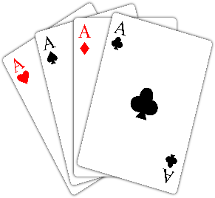

**Beginning October 27, the Sunday afternoon games on the 3rd, 4th and 5th Sundays will change from an open game to ………………………………. “8” is Enough!**

These rules apply:

A players are those with over 2000 masterpoints and contribute 3 “team points”

B players are those with between 750 and 1,999 masterpoints and count as 2 “team points”

C players are those with fewer than 750 masterpoints and count as 1 “team point”

The total team points cannot exceed 8. For example, a team of four B players, or two A and two C players would be allowed, but a team of three A players and one C player would not.

Teams will play 4 six board matches.

 Did you know……………. The Bridge Center uses over 50,000 styrofoam coffee cups in a year? Here’s a thought………why not bring your own coffee cup to bridge, then take it home after the game and bring it back next time? We’ve observed a few players doing this already – THANK YOU!! Wouldn’t it be wonderful for our planet if we ALL did?



**Halloween is Thursday, October 31st. Free lunch for anyone in costume – we’re serving Grilled Cheese 😊**

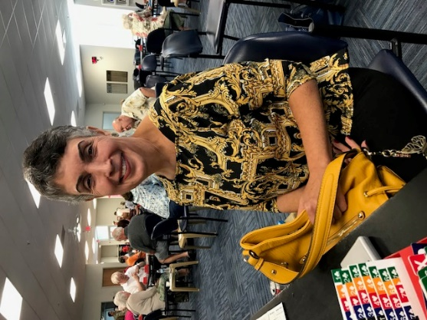 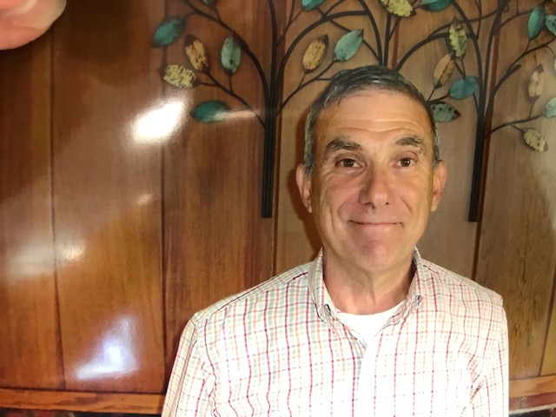

Sue Perez Michael Bono

Sue Perez and Michael Bono were honored before the evening game on Thursday, September 26.

The Bridge-Builder Award was created to honor the duplicate bridge player whose honesty, integrity, competence, zeal, and leadership -in short, professionalism- have earned the respect of the duplicate bridge playing community by playing and participating in the game in the manner in which all should.

It publicly recognizes one who continually strives to balance respect for the game with the competitive spirit of each hand, and in so doing:

​

* Deals honestly with opponents at all times
* Invests the time and energy necessary to improve play
* Conducts oneself with dignity and decorum
* Inspires others to act nobly and professionally
* Encourages others to learn the game.

​

It’s not too early to start thinking about your Club Renewal. Membership renewal is $25 and is due by December 31, 2019. A renewal form is attached, you may pick one up at the Center, or you may pay online through paypal on our website. [www.stlouisbridge.org](http://www.stlouisbridge.org)

St. Louis Magazine

There’s a very interesting article in the most recent St. Louis Magazine regarding playing bridge and prevention of memory loss. The link is attached here for your convenience. [Click Here](https://www.stlmag.com/health/playing-bridge-might-prevent-memory-loss-st-louis-bridge-center/)

Deal Me In